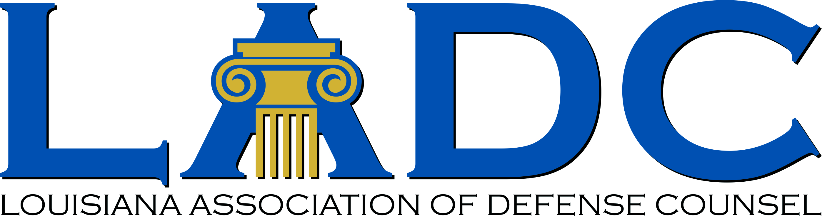


Louisiana Judicial College and
Louisiana Association of Defense Counsel Joint Seminar
The Westin New Orleans - Friday, Dec. 11, 2026

7:30-9:00 am Registration & Breakfast
8:00-8:15 am Welcome Remarks:
Judge Laurie Hulin, President of the Board of Governors, Louisiana Judicial College and
Jimmy Ordeneaux, President of the LADC

8:15-9:15 am Products Liability in the Age of AI (1 Hour)
Prof. Catherine Sharkey, Segal Family Professor of Regulatory Law and Policy, New York University Law School

9:15-9:30 am Break

9:30-11:00 am Recent Developments in Louisiana Tort Law (1.5 hours)
Justice Piper D. Griffin, Louisiana Supreme Court
Prof. Thomas C. Galligan, Jr., LSU Law Center
Thomas M. Flanagan, Flanagan Partners, LLP
Prof. John M. Church, LSU Law Center

11:00-12:00 Recent Developments in Louisiana Civil Procedure (1 hour)
Judge Tiffany Gautier Chase, Louisiana 4th Circuit Court of Appeal
Judge (Retired) Guy Holdridge, Director of the Louisiana State Law Institute
Shiena Marie N. Burke, Kean Miller LLP
Prof. Bill Corbett, LSU Law Center

12:00-1:00 pm Buffet Lunch

1:00-2:00 pm Updates on Insurance Law (1 hour)
Judge Allison H. Penzato, Louisiana 1st Circuit Court of Appeal
Harry J. “Skip” Philips, Assistant Chief Deputy Attorney General

2:00-3:00 pm Ruminations on Jury Instructions (1 hour)
Judge Kelly Balfour, Louisiana 1st Circuit Court of Appeal
Judge (Retired) Guy Holdridge
Prof. Tom Galligan
Prof. Bill Corbett

3:15-3:30 pm Break

3:30-4:30 pm Ethics (1 hour)
Judge Brady O’Callaghan, First Judicial District Court
Prof. Dane Ciolino, Loyola University New Orleans College of Law

4:30-5:30 pm Professionalism- —John Allen Dixon, Jr.: An Exemplary Life of Honor, Service , and Professionalism (1 hour)
E. Phelps Gay, Chair of The Supreme Court of Louisiana Historical Society

CLE Credits: 7.5 hours

