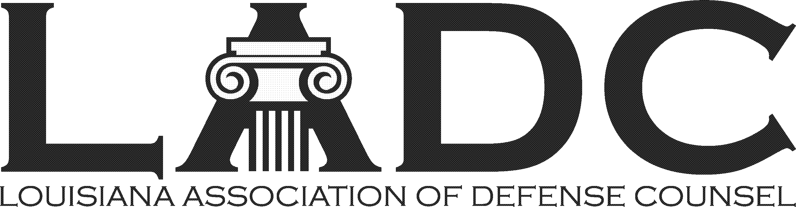

LADC Annual Crawfish Boil
April 6, 2024 – 11:00 am – 2:00 pm
Pontchartrain Yacht Club in Mandeville

Law Firm Sponsorship – $250

Sponsorship includes:
- Logo featured on the LADC’s website and on event signage
- Recognition on digital invitations
- Verbal recognition during the party
- Quarter page color ad in the LADC’s April newsletter

2024 Sponsorship Form

Law Firm Name: ______________________________________________________________

Contact: _____________________________________________________________________

Address: ____________________________________________________________________

Phone: ______________________________________________________________________

Email: _______________________________________________________________________

All LADC members and immediate family are invited to the party!

Make checks payable to the Louisiana Association of Defense Counsel.
Return this form with payment to: LADC, P.O. Box 9430, Metairie, LA 70055-9430.

