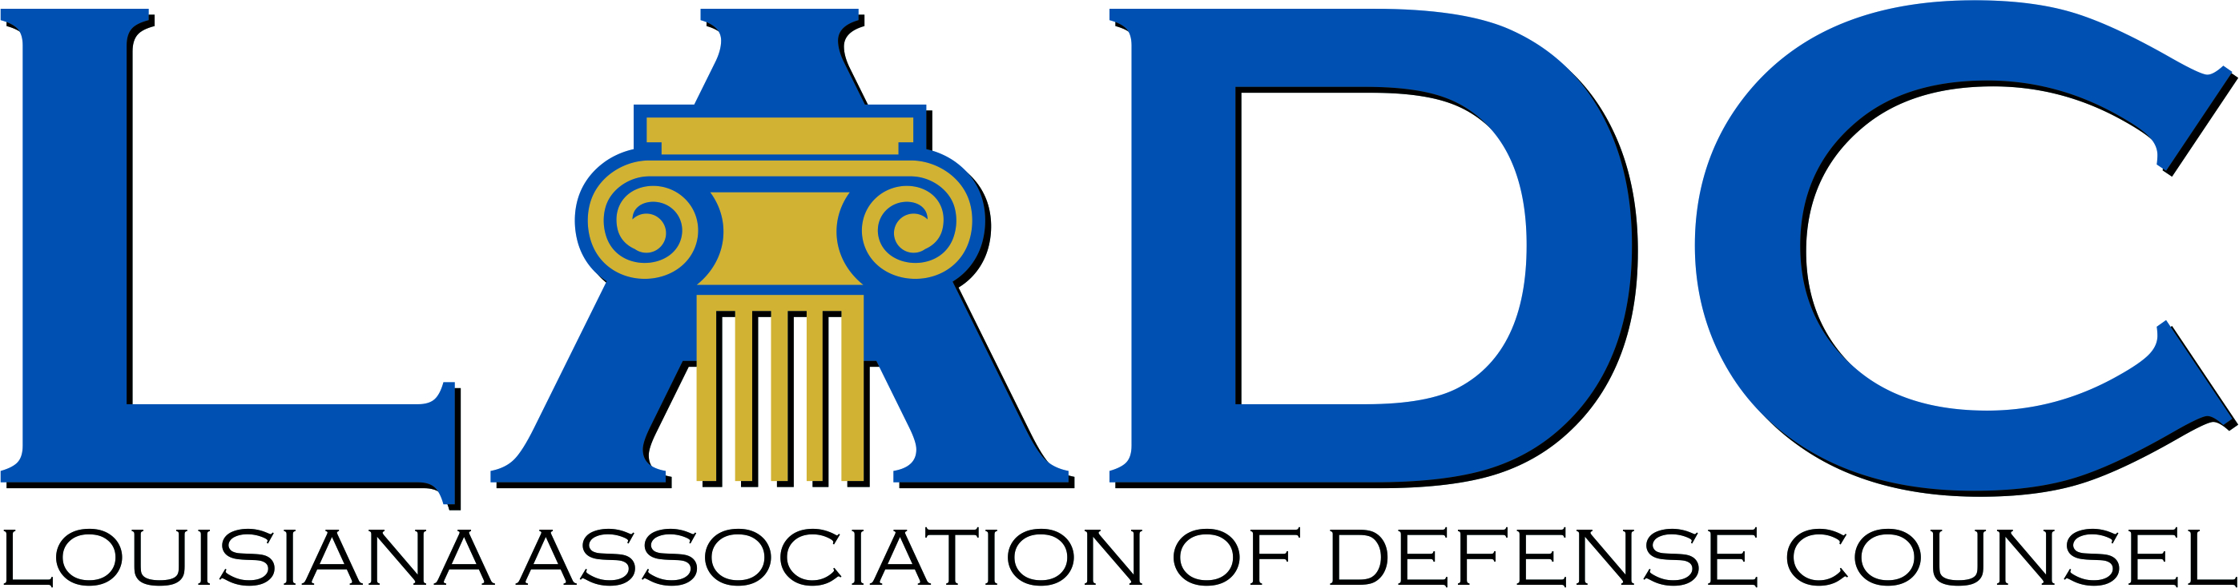


Louisiana Judicial College and
Louisiana Association of Defense Counsel Joint Seminar
The Westin New Orleans - Friday, Dec. 12, 2025

7:30-9:00 am Registration & Breakfast
8:00-8:15 am Welcome Remarks:
Judge Anastasia "Staci" Wiley, President of the Board of Governors,
Louisiana Judicial College and
S. Dennis Blunt, President of the LADC

8:15-9:45 am Recent Developments in Louisiana Civil Procedure (1.5 hours)
Judge Tiffany G. Chase, Louisiana 4th Circuit Court of Appeal
Judge (Retired) Guy Holdridge, Director of the Louisiana State Law Institute
James K. Ordeneaux, Plauché Maselli Parkerson, LLP
Prof. Bill Corbett, LSU Law Center

9:45-10:00 am Break

10:00-11:30 am Recent Developments in Louisiana Tort Law (1.5 hours)
Justice Piper D. Griffin, Louisiana Supreme Court
Prof. Thomas C. Galligan, Jr., LSU Law Center
Thomas M. Flanagan, Flanagan Partners, LLP
Prof. John M. Church, LSU Law Center

11:30-12:30 Torts and Artificial Intelligence (1 hour)
Prof. Jane Bambauer, Levin College of Law University of Florida and Brechner Eminent Scholar Chair, College of Journalism and Communications

12:30-1:30 pm Buffet Lunch

1:30-2:30 pm Updates on Insurance Law (1 hour)
Judge Allison H. Penzato, Louisiana 1st Circuit Court of Appeal
Harry J. “Skip” Philips, Taylor Porter

2:30-3:30 pm Professionalism: The Unwritten Rules of Talking to a Jury (1 hour)
Judge Stephen D. Enright, Jr., 24th Judicial District Court
Judge Stephen C. Grefer, 24th Judicial District Court
Lottie L. Bash, Faircloth Melton Bash & Green, LLC
Rachel G. Webre, Laborde Siegel, LLC
Chris Whittington, Williamson, Campell & Whittington, LLC

3:30-3:45 pm Break

3:45-4:45 pm Ethics (1 hour)
Judge Laurie A. Hulin, 15th Judicial District Court
Prof. Dane Ciolino, Loyola University New Orleans College of Law

7 Total Credit hours

