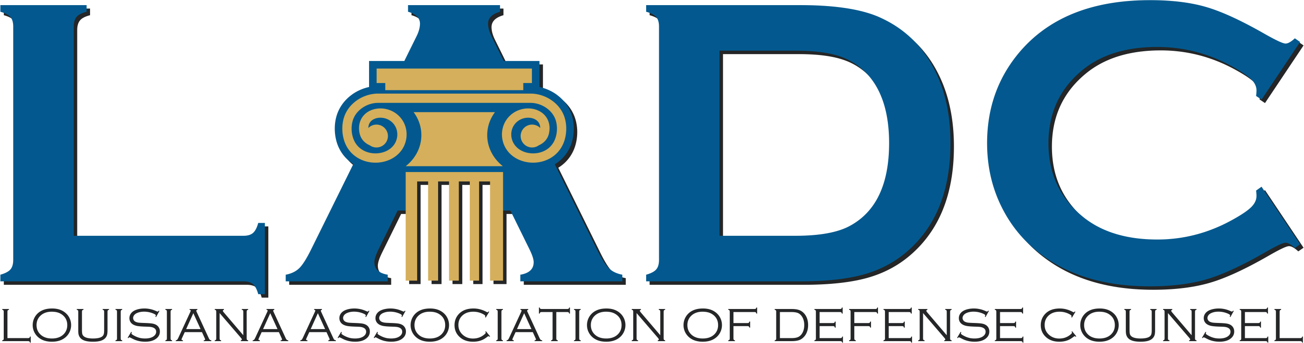
Law Firm Sponsor Table

Young Lawyers & LADC Board Dinner
August 6, 2025 - 6:30 PM

Law Firm Table Sponsor $1200
Table Sponsor receive the following:
- Reserved table of (8) with tabletop signage
- Recognition on LADC website, Facebook, and newsletter (August and September)
- Recognition in Dinner Program and during the Ceremony

        - Sponsor Contact Information
        - Full Name: ________________________________________________________________________________
        - Firm Name: _______________________________________________________________________________
        - Address: __________________________________________________________________________________
        - ______________________________________________________________________________________________
        - Phone Number: __________________________________________________________________________
        - Email Address: ___________________________________________________________________________
- Payment Information:
- Enclosed is check # ______________, payable to the Louisiana Association of Defense Counsel.
- Return this form with payment to:
- LADC P.O. Box 9430, Metairie, LA 70055

