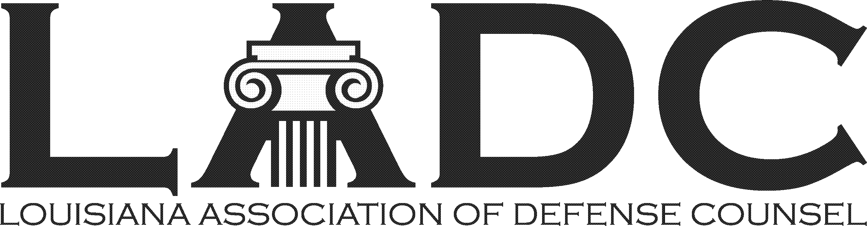

LADC 60th Anniversary Party
April 22, 2023 – 2:00 – 5:00 PM
Pontchartrain Yacht Club in Mandeville

Law Firm Sponsor Benefits - $250

- Logo on Website & Event Signage
- Recognition on digital invitations
- Verbal recognition during Party
- Quarter page color ad in April Newsletter

2023 Sponsorship Form

Company Name: ______________________________________________________________

Contact: _____________________________________________________________________

Address: ____________________________________________________________________

Phone: ______________________________________________________________________

Email: _______________________________________________________________________

All LADC Members and immediate family are invited to the party!

Make checks payable to the Louisiana Association of Defense Counsel
Return this form with payment to: LADC, P.O. Box 9430, Metairie, LA 70055-9430

