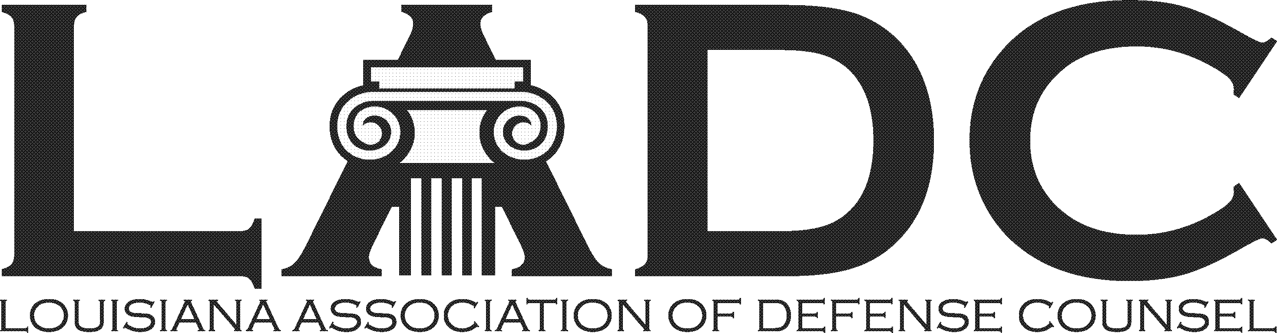

LADC 60th Anniversary Party
April 22, 2023 – 2:00 – 5:00 PM
Pontchartrain Yacht Club in Mandeville

Corporate Sponsorship Benefits - $500

- 2 Tickets to the Party
- Logo on Website & Event Signage
- Recognition on digital invitations
- Verbal recognition during Party
- Quarter page color ad in 2 newsletters

2023 Sponsorship Form

Company Name: ______________________________________________________________

Contact: _____________________________________________________________________

Address: ____________________________________________________________________

Phone: ______________________________________________________________________

Email: _______________________________________________________________________

Make checks payable to the Louisiana Association of Defense Counsel
Return this form with payment to: LADC, P.O. Box 9430, Metairie, LA 70055-9430

